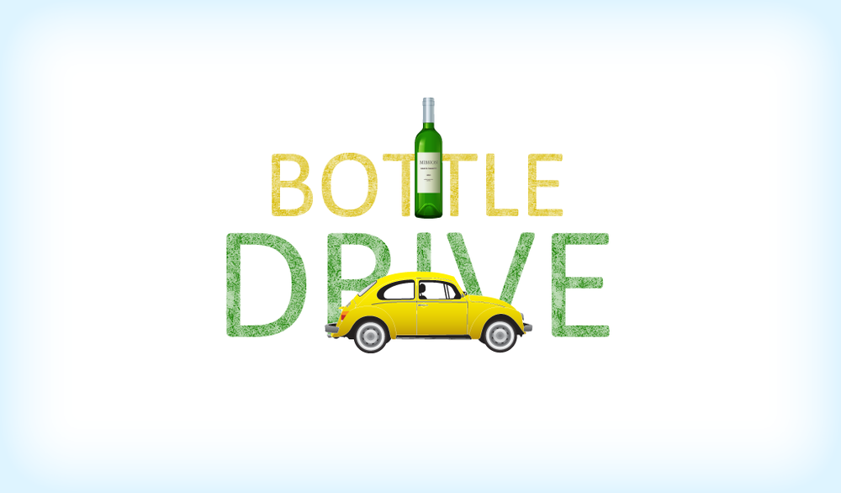

Come support your local community school!

BOTTLE DRIVE
SUNDAY NOVEMBER 17TH
FROM 10 AM TO 2 PM AT
PROSPECT LAKE SCHOOL

All proceeds help fund outdoor activities at Prospect Lake Elementary

