The Prospect Lake PAC has partnered with locally-owned
Red Barn Market (with three locations to serve you) to create a great fundraising opportunity for our school! 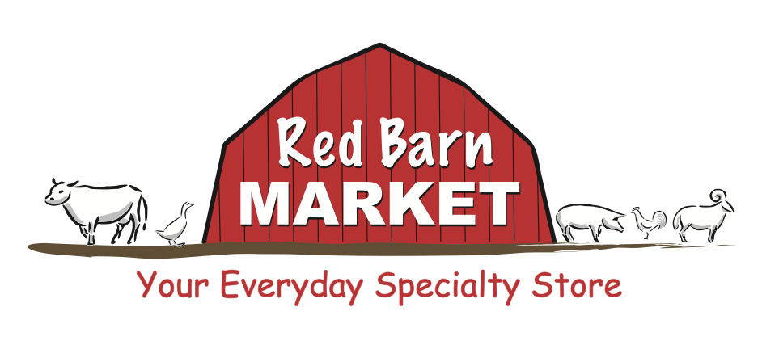
How do I participate?

- Purchase “Barn Bucks” $50.00 gift cards through the PAC to buy your groceries at the Red Barn

- Red Barn will donate 10% of the value of all “Barn Bucks” purchased! $5.00 for every $50.00 you spend is donated back to our school.

- Once per month, I will send out an order form and you can order the cards. Each card is in $50.00 denomination. Please send cheque or cash with your order and let me know how many cards you would like for the month of January. Please return order form by Wednesday, January 15th.
THANK YOU FOR SUPPORTING YOUR SCHOOL
Name: _____________________________ Ph: ________________________
Childs Name:____________________ Teacher:________________________
Yes i would like _____________$50.00 cards for a total of $__________________
I would like to (please check one)
___Pick up my cards at the office ___Put them in my Child`s back pack

