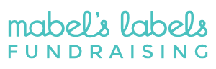

Mabel’s Labels is the best-known brand of durable labels for families. With an ever-growing line of products, there is something for everyone. All labels are extremely durable, they are laundry, dishwasher, and microwave safe, and the best part, they are 100% guaranteed!
By using this link: Fundraising Support | Mabel’s Labels | Raise Funds With Kids Labels (mabelslabels.ca), you are able to shop the entire Mabel’s Labels website. With every purchase you make, Mabel’s Labels gives back 20% to our PAC.
Now is the best time to purchase labels for your child to help ensure their clothing, shoes, lunch containers, and any other personal items they send to school, return to your home.

