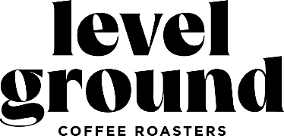

Level Ground started as a Fairtrade Organization (FTO) in 1997 and more than 25 years later, we still pride ourselves on sourcing quality coffee and roasting delicious single origin and craft coffees. You care about what you buy and consume, so do we. Treat yourself to premium coffee at an accessible price. You shouldn’t have to break the bank for your daily coffee.
We have teamed up with our local Saanichton coffee producer, Level Ground for a year-round fundraiser.
Here’s how this fundraiser works:
- Our fundraising code is PLES - share with your friends, family and colleagues!
- Use this code at the end of your purchase in the “Discount Code or Gift Card” space
- The PAC receives 20% commission on ALL order sales.
- Supporters must meet a $50 minimum on their order (which includes free shipping to your door)
- The fundraising code cannot be combined with other sales/promos;
- Gift cards purchased through the site cannot be included in the fundraiser.

