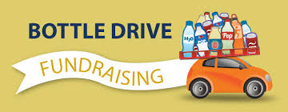

Call your friends, knock on your neighbour’s doors, dig through your recycling, and bring in those empties!

When? Sunday September 19, 2021
Time: 10:00am-2:00pm
Where: Prospect Lake Elementary School

All proceeds raised go directly towards providing our children with new opportunities.

If you need any help bringing in your bottles, or you are interested in volunteering, please contact your PAC at…
prospectlakepac@gmail.com

We thank you in advance for your support!

